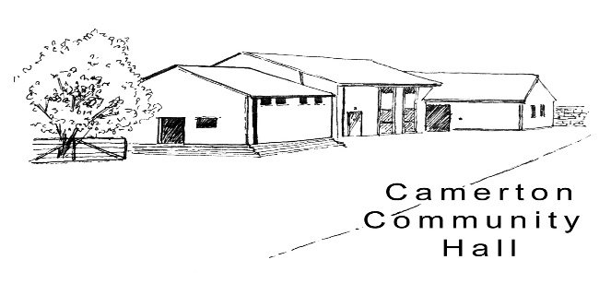

Scattering cremated ashes around a tree.

Many people find the idea of nourishing a new life from their loved-one's cremated remains brings much comfort and solace. However, there are some practical tips to consider first as all cremated remains have naturally high levels of pH and salt. This can interfere with the natural balance of nutrients in the soil and be detrimental to all plant life.

To ensure your memorial tree flourishes, neutralise the high salt and alkaline levels by blending the remains with an ericaceous (acidic) compost which can be purchased at any homeware store or garden centre. It is important to dilute the salt and pH levels generously. Also consider scattering a smaller amount of cremated remains over a larger area so the concentrated levels are diluted further.